STATEMENT OF CASH FLOW
Nguyễn Thị Kim Hương
1. Purpose of the Statement of Cash Flow
The primary purpose of a statement of cash flows is to provide relevant information about the cash receipts and cash payments of an enterprise during a period. To achieve this purpose, the statement of cash flows reports the following: (1) the cash effects of operations during a period, (2) investing transactions, (3) financing transactions, and (4) the net increase or decrease in cash during the period.
2. Content and format of the Statement of cash flow
In accomplishing its purpose, the statement focuses attention on three different activities related to cash flows.
a. Operating activities involve the cash effects of transactions that enter into determination of net income.
b. Investing activities include making and collecting loans and acquiring and disposing of debt and equity investments and property, plant, and equipment.

c. Financing activities involve liability and owners’ equity items and include (1) obtaining resources from owners and providing them with return on their investment and (2) borrowing money from creditors and repaying the amounts borrowed.
The basic format of the statement of cash flows is shown below.
Statement of Cash Flows
Cash flows from operating activities $XXX
Cash flows from investing activities XXX
Cash flows from financing activities XXX
Net increase (decrease) in cash XXX
Cash at beginning of year XXX
Cash at end of year $XXX
The statement’s value is that it helps users evaluate liquidity, solvency, and financial flexibility. Liquidity refers to the “nearness to cash” of assets and liabilities. Solvency is the firm’s ability to pay its debts as they mature. Financial flexibility is a company’s ability to respond and adapt to financial adversity and unexpected needs and opportunities.
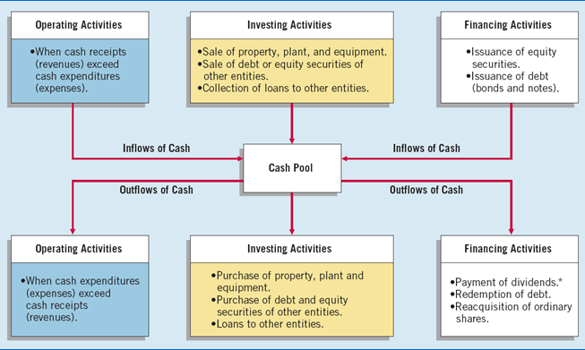

2.3. Overview of the preparation of the statement of cash flow
The information to prepare the statement of cash flows comes from three sources: (a) comparative statement of financial position, (b) the current income statement, and (c) selected transaction data. Preparation of the statement of cash flows involves the following steps.
    - Determine the cash provided by or used in operations.
    - Determine the cash provided by or used in investing and financing activities.
    - Determine the change (increase or decrease) in cash during the period.
    - Reconcile the change in cash with the beginning and the ending cash balances
Net cash provided by operating activities is the excess of cash receipts over cash payments from operating activities. Companies determine this amount by converting net income on an accrual basis to a cash basis. To do so, they add to or deduct from net income those items in the income statement that do not affect cash. This procedure requires that a company analyze not only the current year's income statement but also the comparative statements of financial position and selected transaction data.
Significant Non-Cash Activities
Not all of a company's significant activities involve cash. Examples of significant noncash activities are: 1. Issuance of ordinary shares to purchase assets. 2. Conversion of bonds into ordinary shares. 3. Issuance of debt to purchase assets. 4. Exchanges of long-lived assets.
Significant financing and investing activities that do not affect cash are not reported in the body of the statement of cash flows. Rather, these activities are reported in a
separate note to the financial statements. Such reporting of these non-cash activities satisfies the full disclosure principle.
Usefulness of the Statement of Cash Flows
“Happiness is a positive cash flow” is certainly true. Although net income provides a long-term measure of a company's success or failure, cash is its lifeblood. Without cash, a company will not survive. For small and newly developing companies, cash flow is the single most important element for survival. Even medium and large companies must control cash flow.
Creditors examine the cash flow statement carefully because they are concerned about being paid. They begin their examination by finding net cash provided by operating activities. A high amount indicates that a company is able to generate sufficient cash from operations to pay its bills without further borrowing. Conversely, a low or negative amount of net cash provided by operating activities indicates that a company may have to borrow or issue equity securities to acquire sufficient cash to pay its bills. Consequently, creditors look for answers to the following questions in the company's cash flow statements. 1. How successful is the company in generating net cash provided by operating activities? 2. What are the trends in net cash flow provided by operating activities over time? 3. What are the major reasons for the positive or negative net cash provided by operating activities?
You should recognize that companies can fail even though they report net income. The difference between net income and net cash provided by operating activities can be substantial. Companies sometimes report high net income numbers but negative net cash provided by operating activities. This type of situation can eventually lead to bankruptcy.

