THE ACCOUNTING INFORMATION SYSTEM
Nguyễn Thị Kim Hương

1. ACCOUNTING INFORMATION SYSTEM
1.1. Basic information & the accounting equation
The accounting process can be described as a set of procedures used in identifying, recording, classifying, and interpreting information related to the transactions and other events of a business enterprise. To understand the accounting process, one must be aware of the basic terminology employed in the process. The basic terminology includes: event, transaction, account, real accounts, nominal accounts, ledger, journal, posting, trial balance, adjusting entries, financial statements, and closing entries. These terms refer to the various activities that make up the accounting cycle. As we review the steps in the accounting cycle, the individual terms will be defined
Double-entry accounting refers to the process used in recording transactions. The terms debit and credit are used in the accounting process to indicate the effect
a transaction has on account balances. The debit side of any account is the left side; the right side is the credit side. Assets and expenses are increased by debits and decreased by credits. Liabilities, equity, and revenues are decreased by debits and increased by credits.
In a double-entry system, for every debit there must be a credit and vice-versa. This leads us to the accounting equation: Assets = Liabilities + Stockholders’ Equity

1.4. Financial Statements and Ownership structure
The equity section of the statement of financial position reports the owners’ interest in the assets of the company. A corporation uses Share Capital, Share Premium, Dividends, and Retained Earnings. A sole proprietorship or a partnership uses a Capital account and a Drawing account.
In a corporation, dividends, revenues, and expenses are transferred to retained earnings at the end of a period, so a change in any one of these three accounts affects equity
2. THE ACCOUNTING CYCLE
2.1. Identifying and recording transactions and other events
The first step in the accounting cycle is analysis of transactions and selected other events. The purpose of this analysis is to determine which events represent transactions that should be recorded
Events can be classified as external or internal. External events are those between an entity and its environment, whereas internal events relate to transactions totally within an entity.
2.2. Journalizing
Transactions are initially recorded in a journal, sometimes referred to as the book of original entry. A general journal is merely a chronological listing of transactions expressed in terms of debits and credits to particular accounts. No distinction is made in
a general journal concerning the type of transaction involved. In addition to a general journal, specialized journals are used to accumulate transactions possessing common characteristics.
Illustration 3-1 depicts the technique of journalizing, using the first transactio for Softbyte, Inc. The transaction was:
September 1: Shareholders invested $15,000 cash in the corporation in exchange for ordinary shares

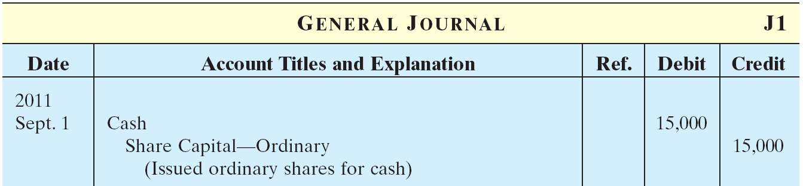
Illustration 3-1: Journalizing
2.3. Posting
The next step in the accounting cycle involves transferring amounts entered in the journal to the general ledger. The ledger is a book that usually contains a separate page for each account. Transferring amounts from a journal to the ledger is called posting. Transactions recorded in a general journal must be posted individually, whereas entries made in specialized journals are generally posted by columnar total.
Posting involves 4 steps (illustration 3-2):
    - Post to debit account – date, journal page number, and amount.
    - Enter debit account number in journal reference column
    - Post to credit account – date, journal page number, and amount
    - Enter credit account number in journal reference column

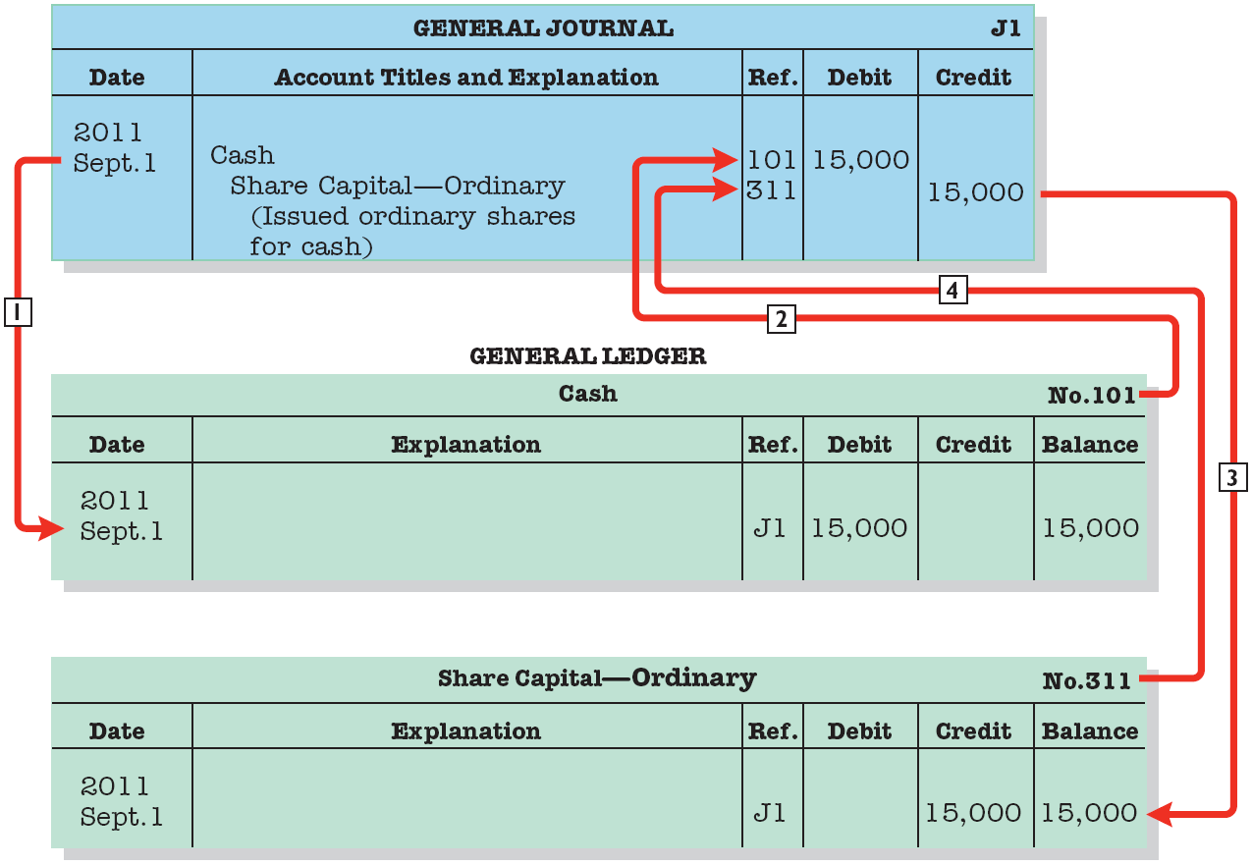
Illustration 3-2: Posting steps
2.4. Trial balance
The next step in the accounting cycle is the preparation of a trial balance. A trial balance is a list of all open accounts in the general ledger and their balances. An entity may prepare a trial balance at any time in the accounting cycle. A trial balance prepared after posting has been completed serves to check the mechanical accuracy of the posting process and provides a listing of accounts to be used in preparing financial statements
Illustration 3-3 presents the trial balance prepared from the ledger, note that the Total Debits equal the total Credits.

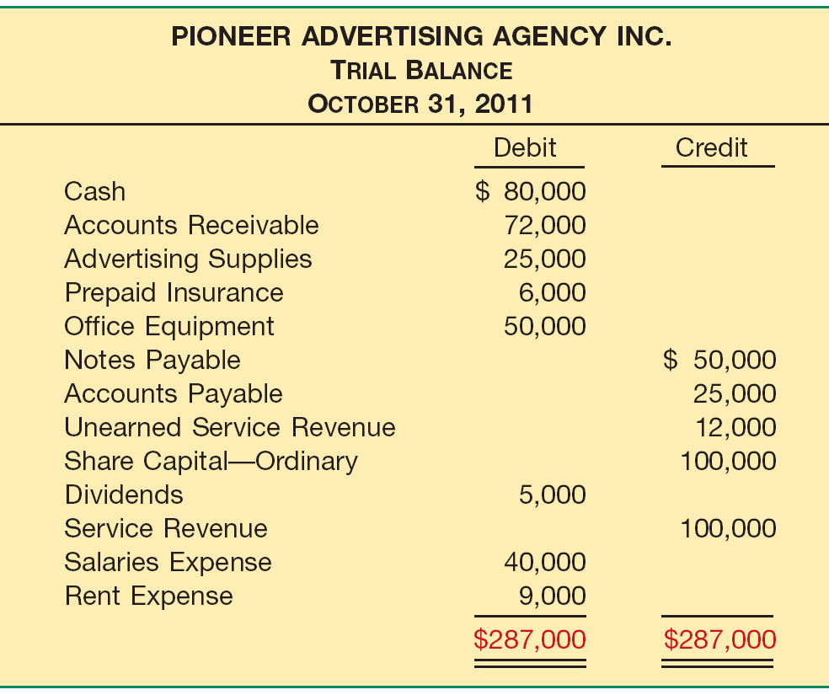
Illustration 3-3: A list of each account and its balance
2.6. Adjusted trial balance
Preparation of adjusting journal entries is the next step in the accounting cycle. Adjusting entries are entries made at the end of accounting period to bring all accounts up to date on an accrual accounting basis so that correct financial statements can be prepared. Adjusting entries are necessary to achieve a proper matching of revenues and expenses in the determination of net income for the current period and to achieve an accurate statement of the assets and equities existing at the end of the period. One common characteristic of adjusting entries is that they affect at least one real account (asset, liability, or equity account) and one nominal account (revenue or expense account). Adjusting entries can be classified as: prepaid expenses, unearned revenues, accrued revenues, and accrued expenses
Adjusting entries are classified as either deferrals or accruals, as follow:

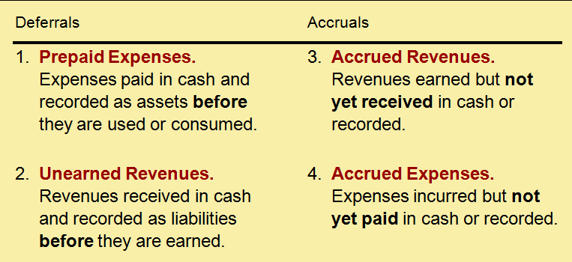
Prepaid expenses and unearned revenues refer to situations where cash has been paid or received but the corresponding expense or revenue will not be recognized until a future period. Accrued revenues and accrued expenses are revenues and expenses recognized in the current period for which the corresponding payment or receipt of cash is to occur in a future period. Estimated items are expenses such as bad debts and depreciation whose amounts are a function of unknown future events or developments
Supplies. An inventory count at the close of business on October 31 reveals that $10,000 of the advertising supplies are still on hand.
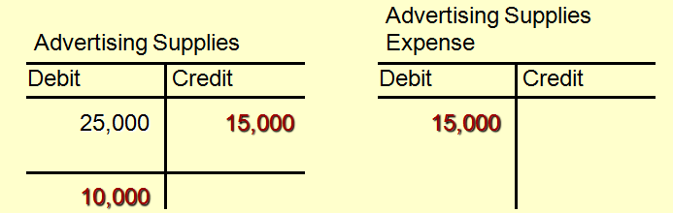
2.7. Preparing financial statements
After adjusting entries are recorded and posted, an adjusted trial balance is prepared. From the adjusted trial balance a company can directly prepare its financial statements
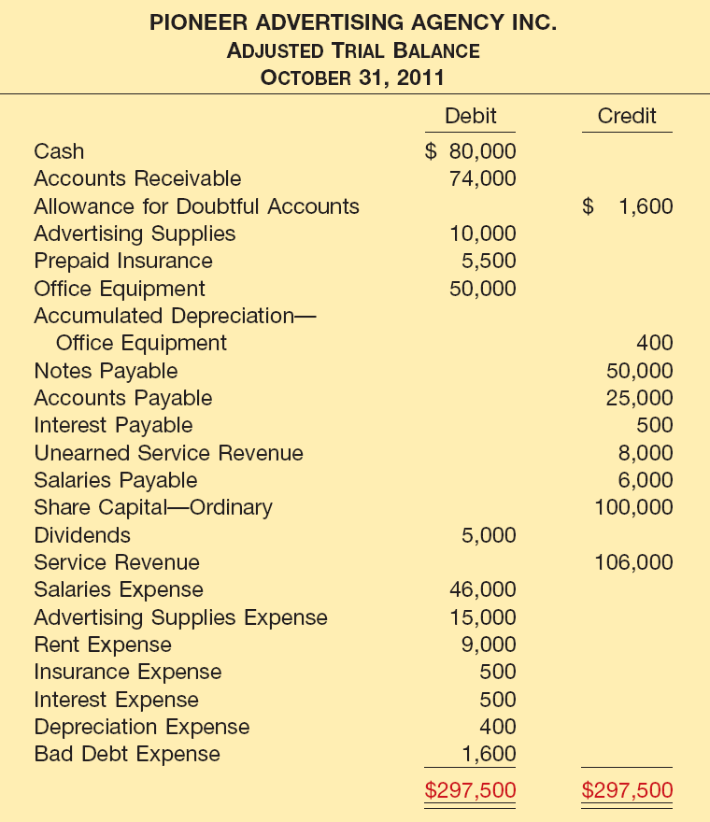
Shows the balance of all accounts, after adjusting entries, at the end of the accounting period.

Illustration 3-5 show the interrelationships of data in the adjusted trial balance and the financial statements.

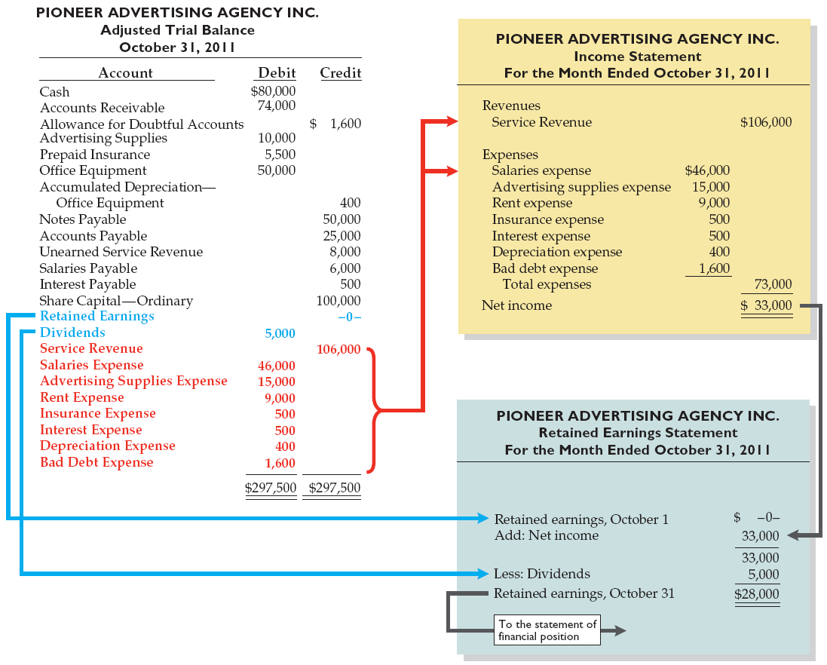

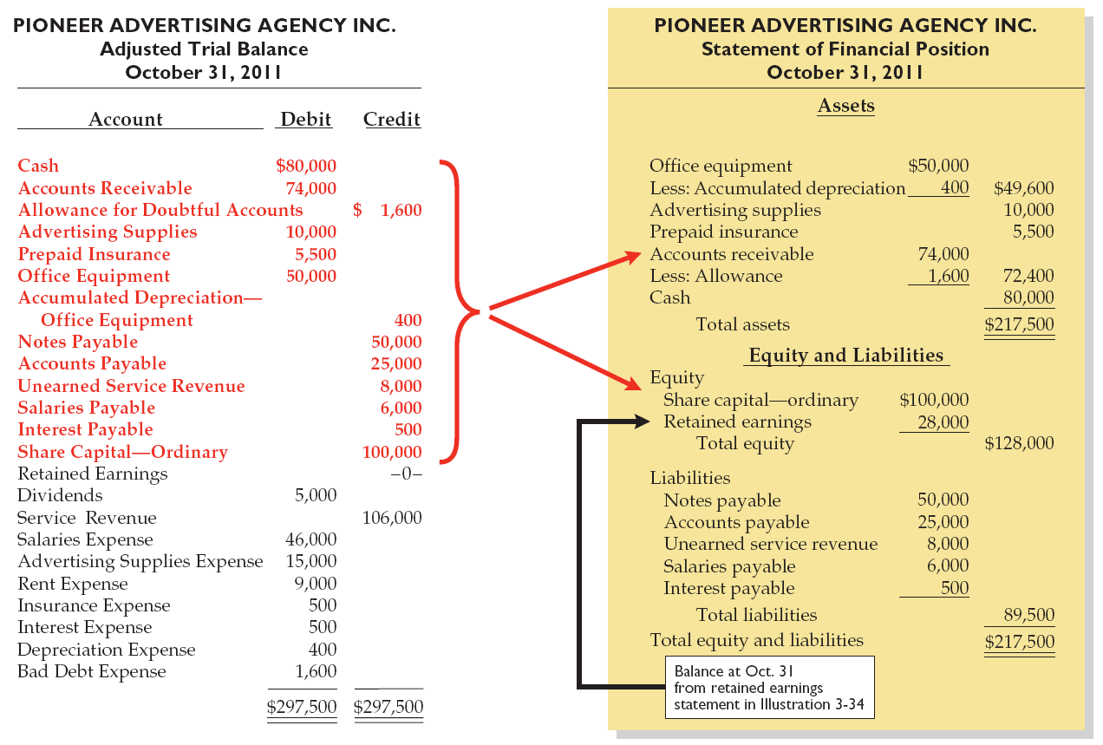
Note: Compare between IFRS and Vietnam Accounting
2.8. Closing
After financial statements have been prepared, nominal (revenues and expenses) accounts should be reduced to zero in preparation for recording the transactions of the next period. This closing process requires recording and posting of closing entries. All revenue and expense accounts are reduced to zero by closing them through the Income Summary account. The net balance in the Income Summary account is equal to net income or net loss for the period. The net income or net loss for the period is transferred to an equity account. For a corporation, the equity account is Retained Earning, for proprietorships and partnerships, it is a capital account. Dividends are closed directly to Retained Earning.

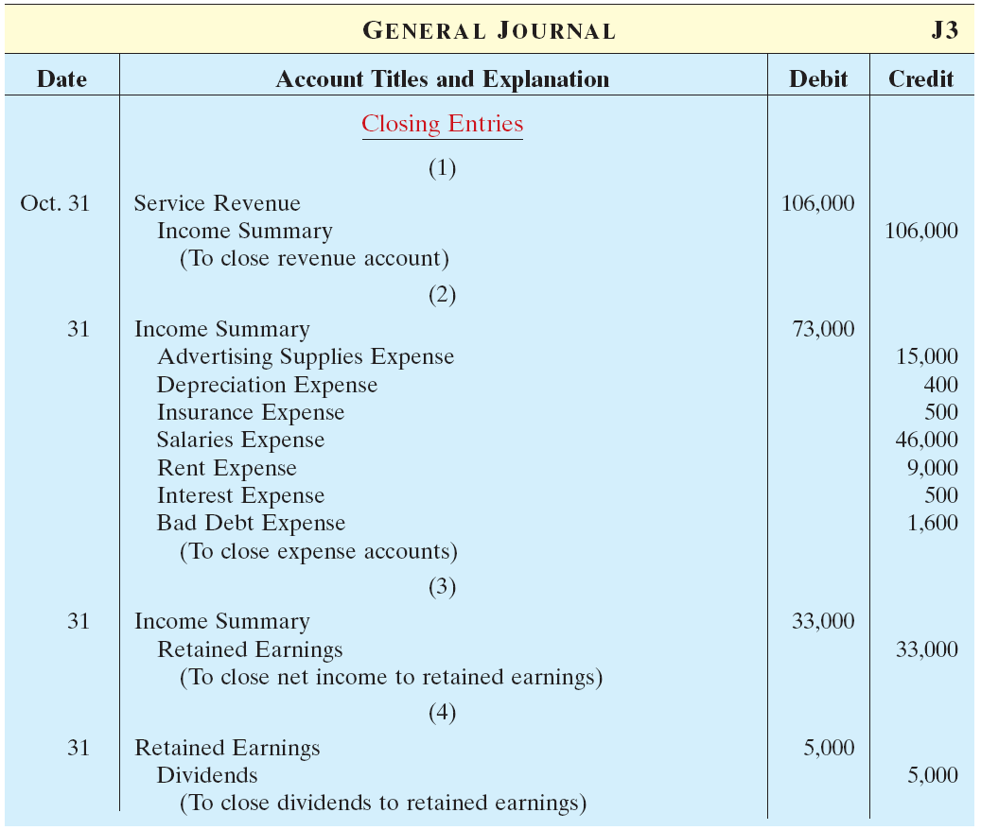
Closing entries journalized
Note: Compare between IFRS and Vietnam Accounting
2.9. Post-closing trial balance
A third trial balance may be prepared after the closing entries are recorded and posted. This post-closing trial balance shows that the company has properly journalized and posted the closing entries.

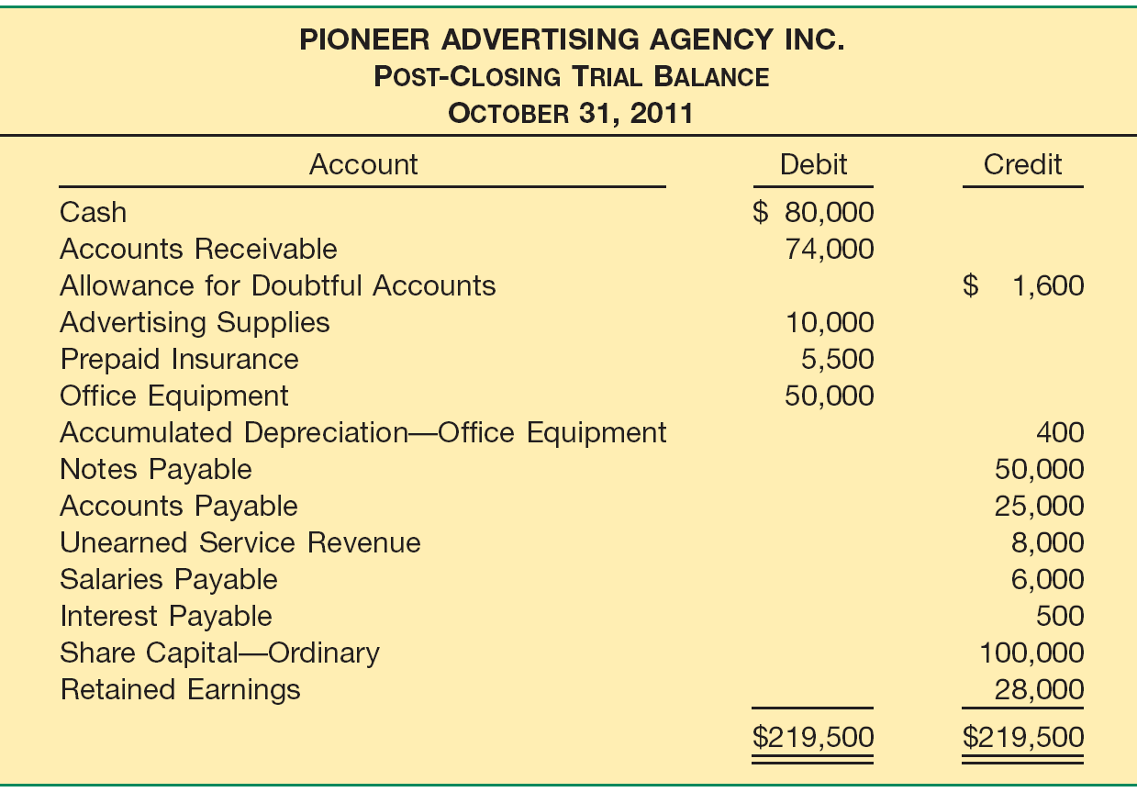

3. FINANCIAL STATEMENTS FOR MERCHANSIERS
3.1. Income Statement
The income statement presented is that of a trading or merchandising concern. If a manufacturing concern were illustrated, three inventory accounts would be involved: Raw Materials, Work in Process, and Finished Goods. When these accounts are used, a supplementary statement entitled Cost of Goods Manufactured must be prepared
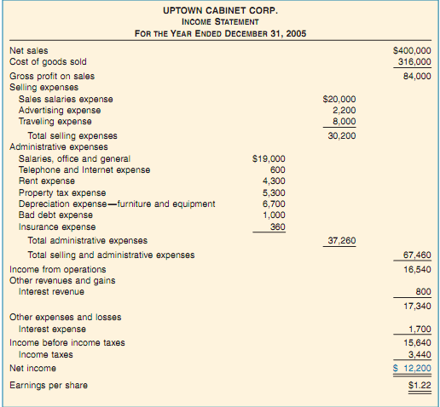
An Income Statement
3.2. Retained Earnings Statement
The net income earned by a corporation may be retained in the business, or it may be distributed to stockholders by payment of dividends. In the illustration, the net income earned during the year was added to the balance of retained earnings on January 1, thereby increasing the balance of retained earnings to $26,400 on December 31. No div- idends were declared during the year

3.3. Statement of Financial Position
The balance sheet prepared from the 10-column work sheet contains new items result- ing from year-end adjusting entries. Interest receivable, unexpired insurance and pre- paid rent expense are included as current assets. These assets are considered current because they will be converted into cash or consumed in the ordinary routine of the business within a relatively short period of time. The amount of Allowance for Doubt- ful Accounts is deducted from the total of accounts, notes, and interest receivable because it is estimated that only $54,800 of $57,800 will be collected in cash.
In the property, plant, and equipment section the accumulated depreciation is de- ducted from the cost of the furniture and equipment. The difference represents the book or carrying value of the furniture and equipment. Property tax payable is shown as a current liability because it is an obligation that is payable within a year. Other short-term accrued liabilities would also be shown as current liabilities. The bonds payable, due in 2010, are long-term liabilities and are shown in a sepa- rate section. (Interest on the bonds was paid on December 31.) Because Uptown Cabinet Corp. is a corporation, the capital section of the balance sheet, called the stockholders’ equity section in the illustration, is somewhat different from the capital section for a proprietorship. Total stockholders’ equity consists of the common stock, which is the original investment by stockholders, and the earnings re- tained in the business
3.4. Closing entries
The entries for the closing process are as follows.

- 