INCOME STATEMENT AND RELATED INFORMATION
Nguyễn Thị Kim Hương
1. INCOME STATEMENT
The income statement, often called the statement of income or statement of earnings, is the report that measures the success of enterprise operations for a given period of time. The business and investment community uses this report to determine profitability, investment value, and credit worthiness. It provides investors and creditors with information that helps them predict the amounts, timing, and uncertainty of future cash flows.
1.1. Usefulness of the Income Statement
The income statement helps users of financial statements predict future cash flows in a number of ways. For example, investors and creditors can use the information in the income statement to:
- Evaluate the past performance of the enterprise. By examining revenues and expenses, you can tell how the company performed and compare its performance to its competitor
- Provide a basis for predicting future performance. Information about past performance can be used to determine important trends that, if continued, provide information about future performance
- Help assess the risk or uncertainty of achieving future cash flows. Information on the various components of income—revenues, expenses, gains, and losses— highlights the relationships among them and can be used to assess the risk of not achieving a particular level of cash flows in the future
1.2. Limitations of the Income Statement
Because net income is an estimate and reflects a number of assumptions, income state- ment users need to be aware of certain limitations associated with the information con- tained in the income statement. Some of these limitations include
- Items that cannot be measured reliably are not reported in the income statement. Current practice prohibits recognition of certain items from the determination of income even though the effects of these items arguably affect the performance of an entity from one point in time to another
- Income numbers are affected by the accounting methods employed. For example, one company may choose to depreciate its plant assets on an accelerated basis; another chooses straight-line depreciation.
- Income measurement involves judgment. For example, one company in good faith may estimate the useful life of an asset to be 20 years while another company uses a 15-year estimate for the same type of asset
In summary, several limitations of the income statement reduce the usefulness of this statement for predicting the amounts, timing, and uncertainty of future cash flows.
1.3. Quality of Earnings
What is earnings management? It is often defined as the planned timing of rev- enues, expenses, gains, and losses to smooth out bumps in earnings. In most cases, earnings management is used to increase income in the current year at the expense of income in future years. For example, companies prematurely recognize sales before they are complete in order to boost earnings. As one commentator noted, “ . . . it’s like popping a cork in [opening] a bottle of wine before it is ready.” Earnings management can also be used to decrease current earnings in order to increase income in the future. The classic case is the use of “cookie jar” reserves. These are established by using unrealistic assumptions to estimate liabilities for such items as sales returns, loan losses, and warranty returns. These reserves can then be reduced in the future to increase income
Such earnings management has a negative effect on the quality of earnings if it distorts the information in a way that is less useful for predicting future earnings and cash flows
2. FORMAT OF THE INCOME STATEMENT
2.1. Elements of the Income Statement
Net income results from revenue, expense, gain, and loss transactions. These transactions are summarized in the income statement. This method of income measurement is called the transaction approach because it focuses on the income-related activities that have occurred during the period. Income can be further classified by customer, product line, or function or by operating and nonoperating, continuing and discontinued, and regular and irregular categories. More formal definitions of income-related items, referred to as the major elements of the income statement, are as follows:
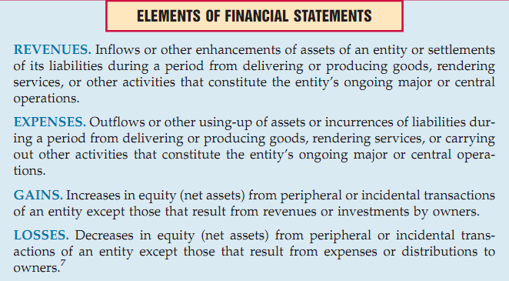
Revenues take many forms, such as sales, fees, interest, dividends, and rents. Expenses also take many forms, such as cost of goods sold, depreciation, interest, rent, salaries and wages, and taxes. Gains and losses also are of many types, resulting from the sale of investments, sale of plant assets, settlement of liabilities, write-offs of assets due to obsolescence or casualty, and theft
2.2. Intermediate Components of the Income Statement
When a multiple-step income statement is used, some or all of the following sections or subsections may be prepared
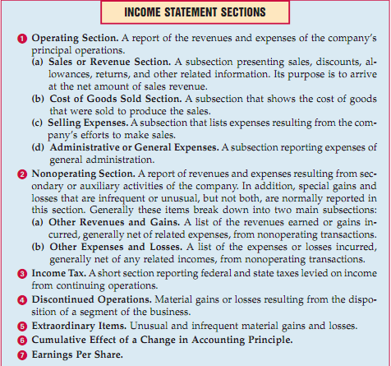
Although the content of the operating section is always the same, the organization of the material need not be as described above. The breakdown above uses a natural expense classification. It is commonly used for manufacturing concerns and for mer- chandising companies in the wholesale trade. Another classification of operating expenses, recommended for retail stores, uses a functional expense classification of administrative, occupancy, publicity, buying, and selling expenses
2.3. Condensed Income Statements
In some cases it is impossible to present in a single income statement of convenient size all the desired expense detail. This problem is solved by including only the totals of expense groups in the statement of income and preparing supplementary schedules to support the totals. With this format, the income statement itself may be reduced to a few lines on a single sheet. For this reason, readers who wish to study all the reported data on operations must give their attention to the supporting schedules
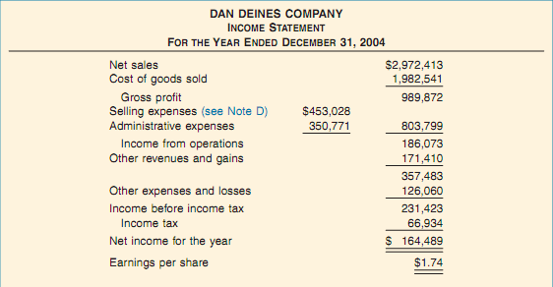
Condensened Income Statement
An example of a supporting schedule, cross-referenced as Note D and detailing the selling expenses, is shown in Illustration bellow:

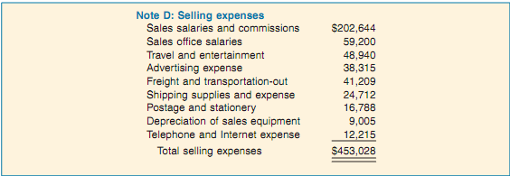
Sample supporting schedule
How much detail to include in the income statement is always a problem. On the one hand, we want to present a simple, summarized statement so that a reader can readily discover important factors. On the other hand, we want to disclose the results of all activities and to provide more than just a skeleton report. Certain basic elements are always included, but as we’ll see, they can be presented in various formats

