STATEMENT OF FINANCIAL POSITION
Nguyễn Thị Kim Hương
1. Classification in the statement of financial position
Statement of financial position accounts are classified. That is, a statement of financial position groups together similar items to arrive at significant subtotals. Furthermore, the material is arranged so that important relationships are shown.
The IASB indicates that the parts and subsections of financial statements are more informative than the whole. Therefore, the IASB discourages the reporting of summary accounts alone (total assets, net assets, total liabilities, etc.). Instead, companies should report and classify individual items in sufficient detail to permit users to assess the amounts, timing, and uncertainty of future cash flows. Such classification also makes it easier for users to evaluate the company’s liquidity and financial flexibility, profitability, and risk.
The three general classes of items included in the statement of financial position are assets, liabilities, and equity:
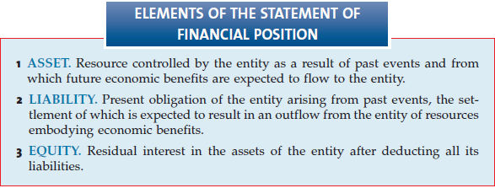
Companies then further divide these items into several subclassifications. Illustration 5-1 indicates the general format of statement of financial position presentation.

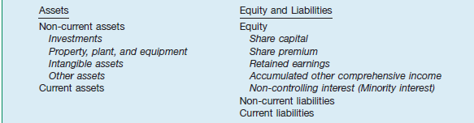
Illustration 5-1: The general format of statement of financial position presentation.
2. Non-Current Assets
Current assets are cash and other assets a company expects to convert to cash, sell, or consume either in one year or the operating cycle, whichever is longer. Non-current assets are those not meeting the definition of current assets. They include a variety of items, as we discuss in the following sections:
- Long-Term Investments
Long-term investments, often referred to simply as investments, normally consist of one of four types:
- Investments in securities, such as bonds, ordinary shares, or long-term notes.
- Investments in tangible assets not currently used in operations, such as land held for speculation.
- Investments set aside in special funds such as a sinking fund, pension fund, or plant expansion fund.
- Investments in non-consolidated subsidiaries or associated companies.
Companies group investments in debt and equity securities into three separate:
- Held-for-collection: Debt securities that a company manages to collect contractual principal and interest payments.
- Trading (also referred to as designated at fair value through profit or loss): Debt and equity securities bought and held primarily for sale in the near term to generate income on short-term price changes.
- Non-trading equity: Certain equity securities held for purposes other than trading (e.g., to meet a legal or contractual requirement).
- Property, Plant, and Equipment
Property, plant, and equipment are tangible long-lived assets used in the regular operations of the business. These assets consist of physical property such as land, buildings, machinery, furniture, tools, and wasting resources (minerals). With the exception of land, a company either depreciates (e.g., buildings) or depletes (e.g., oil reserves) these assets. A company discloses the basis it uses to value property, plant, and equipment; any liens against the properties; and accumulated depreciation—usually in the notes to the statements
Note: Compare between IFRS and Vietnam Accounting
- Intangible Assets
Intangible assets lack physical substance and are not financial instruments. They include patents, copyrights, franchises, goodwill, trademarks, trade names, and customer. lists. A company writes off (amortizes) limited-life intangible assets over their useful lives. It periodically assesses indefinite-life intangibles (such as goodwill) for impairment. Intangibles can represent significant economic resources, yet financial analysts often ignore them, because valuation is difficult. Research and development costs are expensed as incurred except for certain development costs, which are capitalized when it is probable that a development project will generate future economic benefits.
- Other Assets
The items included in the section “Other assets” vary widely in practice. Some include items such as long-term prepaid expenses and non-current receivables. Other items that might be included are assets in special funds, property held for sale, and restricted cash or securities. A company should limit this section to include only unusual items sufficiently different from assets included in specific categories.
3. Current Assets
As indicated earlier, current assets are cash and other assets a company expects to convert into cash, sell, or consume either in one year or in the operating cycle, whichever is longer. The operating cycle is the average time between when a company acquires materials and supplies and when it receives cash for sales of the product (for which it acquired the materials and supplies). The cycle operates from cash through inventory, production, receivables, and back to cash. When several operating cycles occur within one year (which is generally the case for service companies), a company uses the one-year period. If the operating cycle is more than one year, a company uses the longer period.
The five major items found in the current assets section, and their bases of valuation, are shown in Illustration 5-5. These assets are generally presented in the following order.
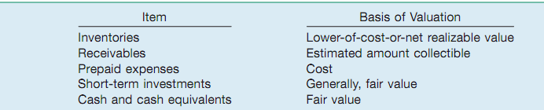
A company does not report these five items as current assets if it does not expect to realize them in one year or in the operating cycle, whichever is longer. For example, a company excludes from the current assets section cash restricted for purposes other than payment of current obligations or for use in current operations. Generally, if a company expects to convert an asset into cash or to use it to pay a current liability within a year or the operating cycle, whichever is longer, it classifies the asset as current.
This rule, however, is subject to interpretation. A company classifies an investment in non-trading equity securities as either a current asset or a non-current asset, depending on management’s intent. When it has holdings of ordinary or preference shares or bonds that it will hold long-term, it should not classify them as current.
- Inventories
To present inventories properly, a company discloses the basis of valuation (e.g., lowerof-cost-or-net realizable value) and the cost flow assumption used (e.g., FIFO or average cost). Presented in Illustration 5-6 is how Royal Ahold (NLD) reports its inventories
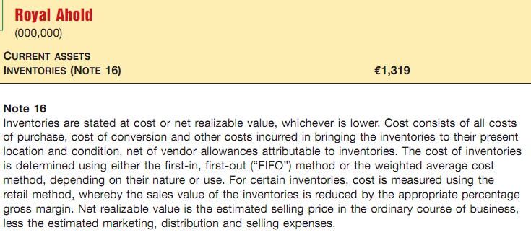
- Receivables
A company should clearly identify any anticipated loss due to uncollectibles, the amount and nature of any non-trade receivables, and any receivables used as collateral. Major categories of receivables should be shown in the statement of financial position or the related notes. For receivables arising from unusual transactions (such as sale of property, or a loan to associates or employees), companies should separately classify these as long-term, unless collection is expected within one year).
- Prepaid expenses
A company includes prepaid expenses in current assets if it will receive benefits (usually services) within one year or the operating cycle, whichever is longer. As we discussed earlier, these items are current assets because if they had not already been paid, they would require the use of cash during the next year or the operating cycle. A company reports prepaid expenses at the amount of the unexpired or unconsumed cost. A common example is the prepayment for an insurance policy. A company classifies it as a prepaid expense because the payment precedes the receipt of the benefit of coverage. Other common prepaid expenses include prepaid rent, advertising, taxes, and office or operating supplies. Adidas (DEU) reports prepaid expenses in other current assets, along with tax receivables other than income taxes and derivative financial assets, as shown Illustration 5-9.
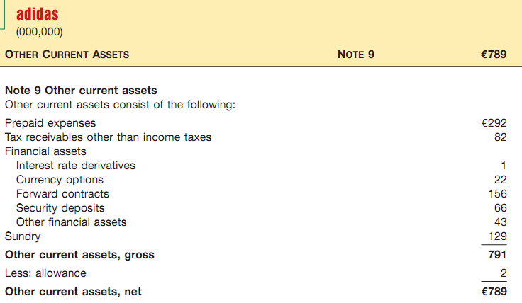
- Short-term Investment
As indicated earlier, a company should report trading securities (whether debt or equity) as current assets. It classifies individual held-for-collection and non-trading equity securities as current or non-current, depending on the circumstances. It should report heldfor-collection securities at amortized cost. All trading and non trading equity securities are reported at fair value
- Cash
Cash is generally considered to consist of currency and demand deposits (monies available on demand at a financial institution). Cash equivalents are short-term highly liquid investments that will mature within three months or less. Most companies use the caption “Cash and cash equivalents,” and they indicate that this amount approximates fair value. As an example, see the excerpt from Adidas (DEU) in Illustration 5-11
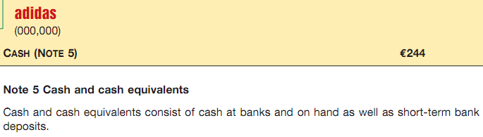
4. Equity
The equity (also referred to as shareholders’ equity) section is one of the most difficult sections to prepare and understand. This is due to the complexity of ordinary and preference share agreements and the various restrictions on equity imposed by corporation laws, liability agreements, and boards of directors. Companies usually divide the section into six parts:
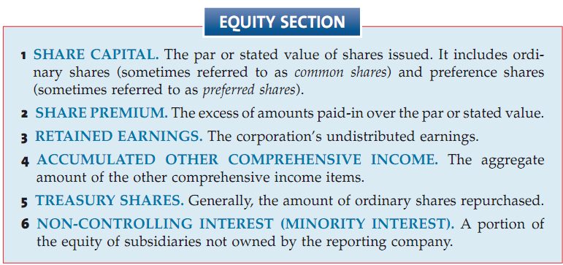

For ordinary shares, companies must disclose the par value and the authorized, issued, and outstanding share amounts. The same holds true for preference shares. A company usually presents the share premium (for both ordinary and preference shares) in one amount, although subtotals are informative if the sources of additional capital are varied and material. The retained earnings amount may be divided between the unappropriated (the amount that is usually available for dividend distribution) and restricted (e.g., by bond indentures or other loan agreements) amounts. In addition, companies show any shares reacquired (treasury shares) as a reduction of equity
5. Non-current Liabilities
Non-current liabilities are obligations that a company does not reasonably expect to liquidate within the longer of one year or the normal operating cycle. Instead, it expects to pay them at some date beyond that time. The most common examples are bonds payable, notes payable, some deferred income tax amounts, lease obligations, and pension obligations. Companies classify non-current liabilities that mature within the current operating cycle or one year as current liabilities if payment of the obligation requires the use of current assets.
Generally, non-current liabilities are of three types:
- Obligations arising from specific financing situations, such as the issuance of bonds, long-term lease obligations, and long-term notes payable.
- Obligations arising from the ordinary operations of the company, such as pension obligations and deferred income tax liabilities.
- Obligations that depend on the occurrence or non-occurrence of one or more future events to confirm the amount payable, or the payee, or the date payable, such as service or product warranties, environmental liabilities, and restructurings, ofter referred to as provisions
6. Current Liabilitie
Current liabilities are the obligations that a company generally expects to settle in its normal operating cycle or one year, whichever is longer. This concept includes:
- Payables resulting from the acquisition of goods and services: accounts payable, wages payable, taxes payable, and so on.
- Collections received in advance for the delivery of goods or performance of services, such as unearned rent revenue or unearned subscriptions revenue.
- Other liabilities whose liquidation will take place within the operating cycle or one year, such as the portion of long-term bonds to be paid in the current period, short-term obligations arising from purchase of equipment, or estimated liabilities such as a warranty liability. As indicated earlier, estimated liabilities are often referred to as provisions.
Current liabilities include such items as trade and non-trade notes and accounts payable, advances received from customers, and current maturities of long-term debt. If the amounts are material, companies classify income taxes and other accrued items separately. A company should fully describe in the notes any information about a secured liability—for example, shares held as collateral on notes payable—to identify the assets providing the security.
The excess of total current assets over total current liabilities is referred to as working capital (or sometimes net working capital). Working capital represents the net amount of a company’s relatively liquid resources. That is, it is the liquidity buffer available to meet the financial demands of the operating cycle
7. Statement of Financial Position Format
IFRS does not specify the order or format in which a company presents items in the statement of financial position. Thus, some companies present assets first, followed by equity, and then liabilities. Other companies report current assets first in the asset section, and current liabilities first in the liability section. Many companies report items such as receivables and property, plant, and equipment net and then disclose the additional information related to the contra accounts in the notes.
In general, companies use either the account form or the report form to present the statement of financial position information. The account form lists assets, by sections, on the left side, and equity and liabilities, by sections, on the right side. The main disadvantage is the need for a sufficiently wide space in which to present he items side by side. Often, the account form requires two facing pages.

