FINANCIAL REPORTING AND ACCOUNTING STANDARDS
Nguyễn Thị Kim Hương
- GLOBAL MARKETS
World markets are becoming increasingly intertwined. And, due to technological advances and less onerous regulatory requirements, investors are able to engage in financial transactions across national borders, and to make investment, capital allocation, and financing decisions involving many foreign companies. As a result, an increasing number of investors are holding securities of foreign companies, and a significant number of foreign companies are found on national exchanges. The move toward adoption of international financial reporting standards has and will continue to facilitate this movement.
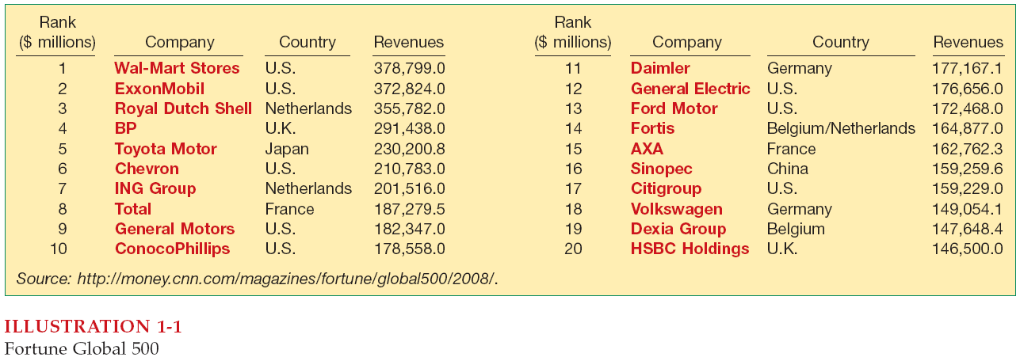
Financial statements and financial reporting
Accounting is the universal language of a business. Financial accounting is the process that culminates in the preparation of financial reports on the enterprise for use by both internal and external parties.
Financial statements are the principal means through which a company communicates its financial information to those outside it. The financial statements most frequently provided are (1) the statement of financial position, (2) the income statement are statement of comprehensive income, (3) the statement of cash flows, and (4) the statement of changes in equity. Note, disclosures are an integral part of each financial statement. Other means of financial reporting include the president’s letter or supplementary schedules in the corporate annual report, prospectuses, and reports filed with government agencies
- STANDARD-SETTING ORGANIZATION
Since 2000, two major standard-setting bodies have emerged as the primary standard-setting bodies in the world. The International Accounting Standards Board (IASB), based in London, United Kingdom and the Financial Accounting Standards Board (FASB), based in the United States
Both boards believe that a single set of high-quality global accounting standards is needed to enhance comparability. It is generally felt that IFRS has the best potential to provide a common platform on which companies can report and investors can compare financial information.
The two organizations that have a role in international standard-setting are the International Organization of Securities Commissions (IOSCO) and the IASB. The IOSCO does not set accounting standards, it is dedicated to ensuring that the global markets can operate in an efficient and effective basis. In 2005 the IOSCO Memorandum of Understanding (MOU) was endorsed to facilitate cross-border cooperation, reduce global systemic risk, protect investors, and ensure fair and efficient securities markets. The international standard-setting structure is composed of four organizations: the International Accounting Standards Committee Foundation (IASCF), the International Accounting Standards Board, a Standard Advisory Council (SAC), and an International Financial Reporting Interpretations Committee (IFRIC).

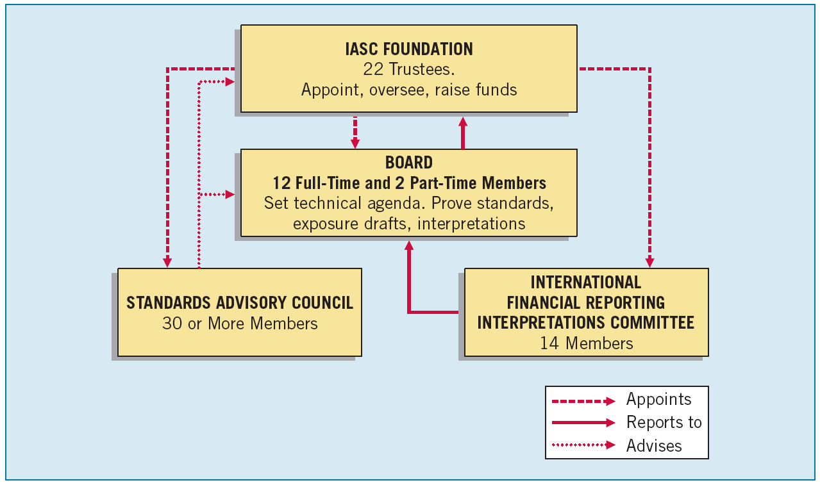
International Standard-Setting Structure

